Nehemiah
Part 4 – Chapter 3

- The people rebuild the wall (3:1-32)

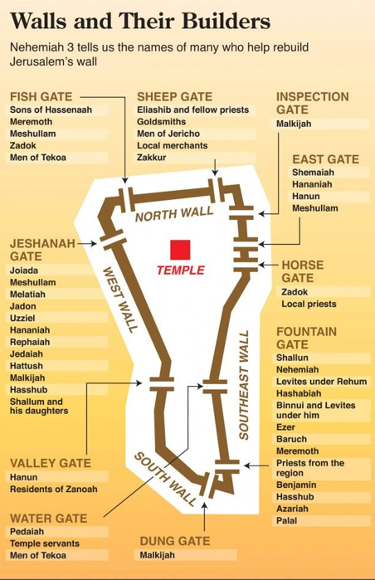
Chart from NIV Quickview Bible (Zondervan, 2012)

- Ridicule and opposition (4:1-3)
  - Why is Sanballat so angry? (v. 1)
  - Why did he complain amongst the wealthy? (v. 2)

- Nehemiah’s response (4:4-5)
  - He turns to ________ (v. 4)
  - Does he go too far? (vv. 4-5)
  - Verse 5 may mean:
    - They have grieved the builders
    - They have offended the builders
    - They have provoked You [God] in the presence of the builders

- Progress report (4:6)
  - A half-height wall was joined together and completed (v. 6)
  - “The heart of the people became/was to do” – What does this mean?

- Leadership insights (chs. 2-4)
  - Leaders think through the when and how of important conversations (v. 2)
  - Leaders “pray with their eyes open” (v. 4)
  - Leaders know how to respectfully appeal to authority (v. 5)
  - Leaders plan and are well prepared (vv. 6-8)
  - Leaders discover the will of God and lead others to discover it and do it (2:17)
  - Leaders help people to see the hand of God at work (2:18)
  - Leaders recognize that any success is of God’s favor and doing (2:8, 20)
  - Leaders and others who strive to do the will of God are often opposed (v. 19)
  - Leaders must be able to organize the work and _____________ a team to work together to accomplish the work (3:1-32)
  - Leaders facilitate a _______________ “heart” amongst the team committed to finishing the task (4:6)

