Nehemiah
Introduction

- Background

  - Author: Ezra or Nehemiah or both (Regardless, note the use of the first person throughout the book which demonstrates that much of the material came directly from Nehemiah)

  - Unity of Ezra-Nehemiah: Probably these two books were originally one book or were intended as a two-part work

  - Timeframe: 446 BC – 424 BC

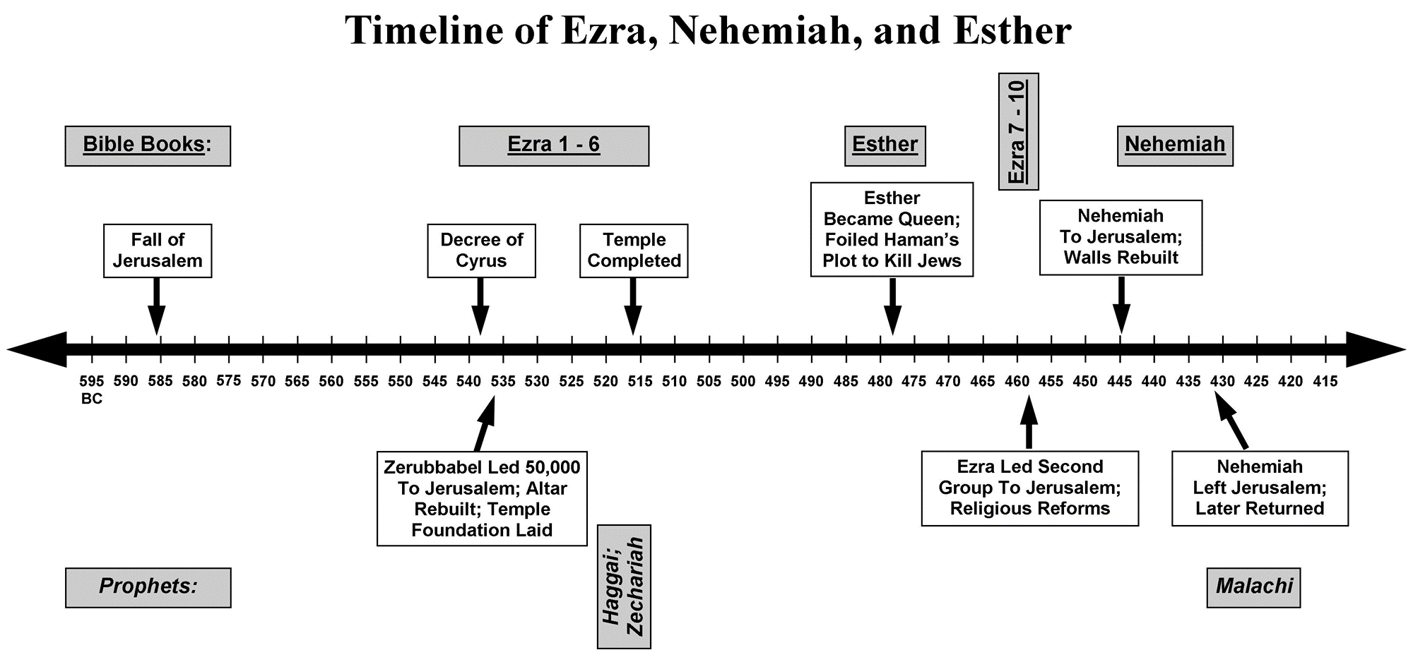

- Timeline:

Text: | Date (BC): | Event:
1:1, 4 | Nov/Dec 446 (Kislev) | Nehemiah hears and prays
2:1, 5 | Mar/Apr 445 (Nisan) | Nehemiah goes to Jerusalem
3:1, 6:15 | Jul/Aug 445 (Ab) | Wall rebuilding begins
6:15 | Aug/Sept 445 (Elul) | Wall completed
7:73 | Sept/Oct 445 (Tishri) | Day of Trumpets
8:13-15 | Sept/Oct 445 (Tishri) | Feast of Tabernacles
9:1 | Sept/Oct 445 (Tishri) | Time of confession
12:27 | Sept/Oct 445 (Tishri) | Wall dedicated
13:6 | 445-433 | Nehemiah’s first term as governor
13:6 | 433-424 | Nehemiah returns to Persia
No ref | 433-? | Malachi prophecies
13:1, 4, 7 | 424-? | Nehemiah returns and serves second term as governer

- Outline:

  - Nehemiah’s return and reconstruction (1:1-7:73)

  - Ezra’s revival and renewal (7:73-10:39)

  - Nehemiah returns (11:1-12:47)

  - Nehemiah’s second term as governor (13:1-31)

